Omar A. Shakir Al Faiadh
201735167@uaeu.ac.ae
Capstone Projecg
HR Analytics about Employee Turnover and its prediction

Approval of the Master Thesis
This Master Thesis is approved by the following Examining Committee Members:

- Advisor (Committee Chair): Dr. Subhadip Pal
Title:

Signature Date

Abstract
Organizations face a significant problem with employee turnover, which affects workforce stability, productivity, and profitability. In order to assist HR departments in identifying at-risk individuals prior to their departure, this thesis will study the major factors driving employee turnover and create predictive models. We performed an exploratory data analysis and used machine learning models to predict turnover using a dataset from an HR department. In order to comprehend the connections between independent factors and employee turnover, the research approach data preprocessing, visualization, and correlation analysis. To forecast employee turnover, we used random forest, logistic regression, decision tree, neural network, logistic regression based on k-means clustering models. To evaluate each model's performance, accuracy was used for validation. According to the results, random forest had the best prediction of employee turnover with a prediction accuracy of 98.2%. According to the data, employee turnover is significantly influenced by independent variables including salary job satisfaction, and the number of years at the company. Utilizing predictive analytics, companies can increase employee retention tactics and lower turnover by taking proactive steps. This research contributes to HR analytics by providing a systematic approach to identifying and mitigating turnover risks through machine learning models.

Keywords: Employee Turnover, Machine Learning, HR Analytics, Predictive Modeling, Random Forest, Logistic Regression, Decision Tree, K-Means, Neural Network.

الملخص
تواجه المؤسسات مشكلة جوهرية تتمثل في الدوران الوظيفي (Employee Turnover)، مما يؤثر على استقرار القوى العاملة وإنتاجيتها وربحيتها. ولمساعدة إدارات الموارد البشرية في تحديد الأفراد المعرضين لخطر المغادرة قبل حدوثها، تتناول هذه الأطروحة العوامل الرئيسية التي تؤدي إلى الدوران الوظيفي (Employee Turnover) وتطوير نماذج تنبؤية. لقد أجرينا تحليلاً استكشافياً للبيانات واستخدمنا نماذج تعلم الآلة (Machine Learning) للتنبؤ بـ الدوران الوظيفي (Employee Turnover) بالاعتماد على مجموعة بيانات من قسم الموارد البشرية. اعتمد النهج البحثي على معالجة البيانات المسبقة (Data Preprocessing)، وتصوير البيانات بصريًا (Data Visualization)، وتحليل الارتباطات (Correlation Analysis) لفهم العلاقة بين المتغيرات المستقلة والدوران الوظيفي (Employee Turnover). ولتوقع الدوران الوظيفي (Employee Turnover)، تم استخدام عدة نماذج تنبؤية، شملت الغابة العشوائية (Random Forest)، والانحدار اللوجستي (Logistic Regression)، وشجرة القرار (Decision Tree)، والشبكات العصبية (Neural Network)، بالإضافة إلى نموذج الانحدار اللوجستي المستند إلى تجميع K-Means (Logistic Regression based on K-Means Clustering). وقد تم تقييم أداء كل نموذج من خلال دقة التنبؤ (Prediction Accuracy)، حيث أظهرت النتائج أن نموذج الغابة العشوائية (Random Forest) كان الأكثر كفاءة في التنبؤ بـ الدوران الوظيفي (Employee Turnover) بمعدل دقة بلغ 98.2%. وتبين من التحليل أن الدوران الوظيفي (Employee Turnover) يتأثر بشكل كبير بمتغيرات مستقلة مثل الراتب (Salary)، والرضا الوظيفي (Job Satisfaction)، وعدد السنوات في الشركة (Years at Company). ومن خلال الاستفادة من التحليلات التنبؤية (Predictive Analytics)، يمكن للمؤسسات تعزيز استراتيجيات الاحتفاظ بالموظفين (Employee Retention Strategies) وتقليل معدل الدوران الوظيفي (Employee Turnover) عبر اتخاذ تدابير استباقية. وتساهم هذه الدراسة في مجال تحليلات الموارد البشرية (HR Analytics) من خلال تقديم نهج منهجي لتحديد مخاطر الدوران الوظيفي (Employee Turnover) والتخفيف منها باستخدام نماذج تعلم الآلة (Machine Learning).

Contents:
Chapter 1: Introduction.
1.1 Overview
1.2 Terminology and types of Turnover.
1.3 Why do we want to decrease employee turnover rates?
1.3.1 Cost and time
1.3.2 The growth and survival of organizations
1.3.3 Production operations and performance.
1.3.4 The loss of skill and Knowledge.
1.4 Problem statement and objectives.

Chapter 2: Literature Review
2.1 Factors Affecting Employee Turnover.
2.1.1 Overview and Development of Predictors of Turnover.
2.1.2 Individual-Level Factors.
2.1.3 Team-Level Factors.
2.1.4 Organizational-Level Factors.
2.1.5 External and Market-Level Factors.
2.1.6 Mediating Factors and Theoretical Frameworks.
2.1.7 Detailed Classification of Causes of Turnover.
2.1.8 Strategies to Reduce Employee Turnover.
2.2 How to Avoid Employee Turnover?
2.2.1 Importance of Interpersonal Relationships and Understanding Employee Needs.
2.2.2 Strategies to Reduce Turnover.
2.2.3 Role of Employee Engagement and Job Embeddedness.
2.2.4 Improvement in Job Satisfaction and Work Environment.
2.2.5 Holistic Retention Strategies.
2.3 Challenges and recommendations.
2.4 Techniques used in previous research.
2.5 Gap in research.

Chapter 3: About Data and Data exploration
3.1 Introduction for data.
3.2 About Data and Summary Statistics.
3.2.1 About Data.
3.2.2 Statistics.
3.3 Visualizations.
3.4 Missing data.
3.5 Correlation Analysis.
3.6 Structural Equation Modeling.

Chapter 4: Methodology
4.1 What are the types of analysis that will be used?
4.2 Decision Tree.
4.3 Logistic regression.
4.4 Random Forest.
4.5 Neural Network.
4.6 K-Means.
4.7 The workflow on KNIME for the exploratory analysis and models.
4.8 Logistic regression based on k-means on KNIME.
4.9 Portioning 60%-40% and 80%-20%.

Chapter 5: Results.
5.1 Logistic Regression Results.
5.2 Random Forest results.
5.3 K-Means.
5.4 Decision Tree.
5.5 Neural Network.
5.6 Logistic Regression based on K-Means Results.
5.7 Models Comparison.

Chapter 6: Conclusion.
6.1 Summary of Findings.
6.2 Implications
6.3 Limitations
6.4 Future Work
6.5 Conclusion

References

Chapter 1: Introduction.
In this chapter, we discuss the concept of the employee turnover. Specifically, we start by defining the employee turnover in an organization. Thereafter, we provide a brief overview of various related concepts including the various types of employee turnover. We aim to statistically model the employee turnover and assess the impact of employee turnover on the organizations. We formulate the problem statement that we want to address in this research and set the objectives within this research.

1.1 Overview
Employee turnover and identification of strategies for employee retention is one of the central topics in human resources [107]. Understanding the underlying factors that may lead to employee turnover is an important area of study and it can assist in identifying appropriate strategies for higher employee retention. Also, the prediction of employee turnover may help organizations to intervene in a timely manner to prevent it or to prepare appropriately to minimize the disruption that may cause due to a possible turnover.

1.2 Terminology and types of Turnover.
The definition of employee turnover was explained by some researchers in different ways and at different times. In earlier literature, it is often defined to be a deliberate desire to leave an organization [107]. Employee turnover is measured as the percentage of employee leaving the organization or getting replaced [107]. In more recent literature, the turnover-intention is defined as the desire of an employee or a worker to leave the organization or the current position to seek for employment in another organization or a different position in the same organization [107] (need more citation). In general. employee turnover was categorized into 3 different types based on the will to leave the company (voluntarism), whether it is within the organization or not (internal or external), and the skills of the employee (skilled or unskilled [107].
-Category 1: The will to leave a company.
Involuntary turnover is defined as an employee's termination because of a bad performance, a violation of the organization's policies, or absenteeism [107]. On the other hand, voluntary turnover is a decision made by the employee himself/herself, to leave an organization [107]. We can classify the turnover as voluntary when the decision of terminating the relationship with the organization is made by the employee, not the employer [2]. Voluntary turnovers can be categorized into functional turnovers, and dysfunctional turnovers. Functional turnovers are defined as the turnover of an employee who had a low performance, while the dysfunctional turnovers are termed as the situation when it happens to an employee who had high performance [2]. A few of the possible reasons for voluntary turnover can be moving out of the city or the area to a new one, personal decisions, finding better job opportunities from other employers [107].
-Category 2: Is the turnover within the company (internal) or outside of the company (external)?
Internal employee turnover occurs when an employee takes on new duties within the same company or organization, while external employee turnover is when the employee leaves the company or organization and moves to a new company or organization [107].
-Category 3: The skills of the employee (skilled or unskilled).
Often, the turnover of the unskilled employees is more frequent than that of the skilled employees. However, it is easier for organizations to replace unskilled employee compared to finding a replacement for skilled employees. Chances of loss in performance and productivity is higher when a skilled employee turnover [107].

1.3 Why do we want to decrease employee turnover rates?
The high rates of employee attrition impact many important factors in any organization. The consequences of this impact are often considered as difficult to mitigate. The cost of employee turnover that companies face might affect negatively to their productivity and performance [5]. Often, employee turnover is considered to be one of the most important issues in managing an organization because of many consequence associated with the turnover of an employee such as the recruitment costs for looking for a new employee to replace the one had left, the time and productivity loss within the period of employee turnover and finding a replacement, and the loss of effort and time to train the new hired employees [5]. Moreover, if for an organization, the employee turnover increase, then it may need to allocate and spend more money and time on hiring and training the new employees. Apart from the cost of recruiting, Employee turnover may cause stress and burnout due to excessive workload for the existing employees. It may also negatively influence the attitudes of the existing employees [8]. [12] also indicates that high turnover rates within an organization may lead to high training costs for newcomers, low enthusiasm and productivity from current employees, increase in the pressure on the rest of employees, and high loss of human resources.
We can address these consequences as following:

1.3.1 Cost and time
Cost and time are two of the essential factors in the success of any organization. The higher the employee turnover is, the higher the total cost and the time spent on training new employees will be [107]. When the cases of employee turnover increase, the organization still must fill the empty position or replace the employees who left the organization by recruiting new employees, which would result in higher costs of investment in recruitment and employee development [12]. These consequences are for all kinds of organizations. For example, the hospitality companies suffer financially of loss in productivity, recruitment, selection, and training costs when employee turnover cases increase [3].

1.3.2 The growth and survival of organizations.
When it comes to organizational growth and survival, employees play an important role, which makes it necessary to keep them as long as possible [10]. Employee turnover could affect negatively on the sustainability of the organization [12]. So, it is important to study employee turnover to avoid the collapse of the organization and the lack of growth within it.

1.3.3 Production operations and performance.
Besides the impact of employee turnover on costs, the high number of turnover cases affects the production operations of the entire organization [12]. [1]'s research emphasized that the employee turnover affects negatively organizational performance.

1.3.4 The loss of skill and Knowledge.
The negative impact of employee turnover does not stop there, where this could affect negatively on the organization on a different level. When we talk about the negative effect of employee turnover on the organization's level, then when the employees leave their organization, they take with them their experience and knowledge that they acquired from working in the organization [5].

1.4 Problem statement and objectives.
If organizations want to increase their productivity and their profit, they need to address the problem of employee turnover [5]. Decreasing the employee turnover cases benefits both businesses and employees [5]. As was discussed in the previous sections. Employee turnover is a serious problem that many organizations suffer from, and they need to address it, understand its causes, and address it before it happens for at-risk employees. The problem that this thesis will address is the employee turnover, the variables that affect it, and the methods to predict it. After understanding the employee turnover terminology and having a look at its impact in previous sections, we can set the objectives that this thesis would try to achieve. In this thesis, we will conduct analysis on an HR department dataset to achieve several objectives:
1-to study the influence of several variables on employee turnover and understand the correlation between these variables and the employee turnover
2-to build several predictive models, using machine learning, that would help HR departments in predicting the at-risk employees before they leave the company. Which would help them in preventing the turnover from happening.
3-to identify the best model in turnover prediction by comparing the results of those predictive models.

Chapter 2: Literature Review
In the previous chapter, we had a closer look at employee turnover, we understood what employee turnovers is and what are its types, we set the problem statement that we want to address, and we set the objectives of this thesis. In this chapter, we will provide a literature review about recent articles to help us understand several aspects of employee turnover such as the factors that influence employee turnover, investigate how to avoid or decrease the high number of employee turnover cases, and understand the recommendations and challenges within previous research. Afterwards, we will investigate the techniques used in previous research to help us in setting the methodology in chapter 4. Last, we will understand the gap in research and have a look about some machine learning techniques for employee turnover prediction.

2.1 Factors Affecting Employee Turnover.

2.1.1 Overview and Development of Predictors of Turnover.
There are several factors that influence the employee turnover and help in turnover prediction. The factors used in employee turnover prediction evolve with the changes in humans’ nature [1]. In this section we will dive into recent articles to investigate the factors that influence employee turnover prediction.

2.1.2 Individual-Level Factors.
There are several individual-level factors that influence employee turnover. One of these factors is job satisfaction, where [12] found that it influences positively on employee turnover intention in a high significance level. Furthermore, [5] mentioned that some of the reasons which make the employees leave their organizations are job satisfaction, job stress, job security, wages, work environment, rewards, and motivation. Moreover, unmet expectations about the work or workplace, mismatch of job and individual, deficiency in proper training and feedback, constraint career growth opportunities, feelings of not being valued or appreciated, too much stress due to excessive workload and poor work/life balance, and erosion of trust in the leaders are considered some common push factors that will eventually make employees leave an organization [5]. Another factor influencing employee turnover is the expectation of job fit and existence of alternatives. According to [12], the interdependence theory states that "when externals are perceived as many job alternatives as possible, employees tend to leave the company voluntarily and when external job alternatives are scarce, employees are more likely to be less involved in actual turnover." Moreover, when the number of good jobs offers increases, the employee turnover intention increases because of the high perception of external job alternatives that employees would have through new opportunities in the market [12].

2.1.3 Team-Level Factors.
Support from team members, whether emotional or practical, is one factor that affects turnover among employees [1]. Moreover, the department where the team is attached plays a role in turnover [1]. The quality of interpersonal relationships in the team is one of the team-related factors that have emerged when considering quitting [1]. There is some indirect impact on organizational outcomes. Though employee turnover is influenced by both team-level and organizational-level factors, the influence of team-level factors may be mainly indirect through their effects on organizational or individual factors rather than as a direct impact [1].

2.1.4 Organizational-Level Factors.
There are several reasons that force the employees to leave their workplaces, such as work stress, dissatisfaction with their roles, lack of job security, workplace conditions, lack of motivation, insufficient pay, and rewards given to them [5]. Ineffective leadership and management skills were also pointed out as reasons for employee turnover [5]. Common reasons for employees to quit are lack of training opportunities, lack of feedback, difficulties in the job, inability to trust, high tension in work, unpleasant tasks, low level of job satisfaction, inappropriate environment, family pressures, and low wages, being with a big team, and poor leadership or management practices [5]. Also, organizational justice and work-life balance influences employee thrives over. Research highlights that perceptions of organizational justice and a balanced work-life dynamic significantly influence employees' intentions to leave their roles [110]. Employee engagement serves as a mediator where organizational justice and work-life balance indirectly reduce turnover intentions, as demonstrated in the context of PT. BSB Kalla Group [110]. Another factor that influences employee turnover is career development opportunities. Factors such as prospects for career growth, higher earning potential, conflicts with coworkers, substandard HR policies, and personal motivations have been identified as contributing to turnover intentions [5]. Changes in management practices, behaviors of senior leaders, and organizational variables—including improved benefits, enhanced employee involvement, and favorable work environments—can add value for employees and help mitigate turnover rates [5].

2.1.5 External and Market-Level Factors.
[5] found causes for employee turnover among three major dimensions. One considers factors pertaining to the job, namely, job satisfaction, wages, performance, and organizational commitment [5]. The second considers personal variables of age, education, gender, and tenure [5]. The last deals with external factors, notably the level of unemployment, job opportunity perceptions, and also the presence of trade unions [5].

2.1.6 Mediating Factors and Theoretical Framework.
Social capital itself cannot exert influence directly on a staff intending to leave. Nevertheless, social capital increases satisfaction which reduces turnover rate 109. Employees engagement is another important attribute for making an intention of quitting factors. The degree of staff becoming engrossed dictates them quit their jobs directly 110. [1] suggested that a person with high levels of "fit," "link," and "sacrifice" is more likely to stay in the job, which determines the turnover rate. Organizational and team level factors are mediated by individual-level factors, and therefore, it is possible that individual factors may predict future turnover but are not the causes [1].

2.1.7 Detailed Classification of Causes of Turnover.
[5] found that job stress, engaging work, and job satisfaction are related to employee turnover and absenteeism. The engaging and challenging work influences an employee's decision to stay with or leave an organization [5].

2.1.8 Strategies to Reduce Employee Turnover.
Involving employees in decision-making and problem-solving can lead to better productivity, more positive attitudes, and reductions in absenteeism and turnover [5].

2.2 How to Avoid Employee Turnover?

2.2.1 Importance of Interpersonal Relationships and Understanding Employee Needs.
Employees are not likely to think about leaving the company where interpersonal relationships, mutual trust, and respect mean the high degree of their overall satisfaction [109]. Understand the needs of workers: Organizations should know such needs and take measures on ways to improve performance while trying to control turnover [5]. Only then can organizations provide necessary conditions for better work and reduce turnover [5].

2.2.2 Strategies to Reduce Turnover.
Managers should therefore take a proactive approach in minimizing employee turnover intentions by emphasizing the physical, emotional, and mental well-being of their staff [109]. Retention strategies that are effective include robust management systems, training opportunities, job involvement and satisfaction, rewards and benefits, high employee engagement, and active participation from employees [5]. These benefits accrue to organizations that have succeeded in preventing turnover through job training programs that enhance performance and minimize employee loss. Coaching has also remained a key duty of the manager [5]. Open communication with employees on challenges, creating an empathetic culture, and reevaluation of job roles and responsibilities are some of the other measures that have been tried with reasonable success [8].

2.2.3 Role of Employee Engagement and Job Embeddedness.
The well-implemented strategies of employee engagement have a positive effect on the intentions of quitting, enabling the employees to do their work without replacement [110]. Retention strategies include creating a favorable environment by organizing interactive activities among the staff, facilitating work-life balance, promoting the career of employees, improving working conditions, inducing happiness, providing new opportunities, renewal of contracts, and matching jobs with the skills, passion, and personality of employees [8]. Organizations also focus on enhancing job embeddedness, which improves retention and reduces costs associated with recruitment and training [121]. Besides, alignment of employees with their community and local lifestyle has also been acknowledged as a reason for retention [8].

2.2.4 Improvement in Job Satisfaction and Work Environment.
A good work environment is the key to retaining employees within an organization. The indirect paths, such as the quality of team relationships and the individual job satisfaction, reduce job stress and therefore improve the working conditions of employees to decrease the intentions of turnover ratio [1]. Talent identification and development can influence increased productivity, satisfaction, motivation, and commitment but reduced turnover levels [10]. Employees tend to deliver more value for better performance as they operate in jobs for which their skills and capabilities match [12].

2.2.5 Holistic Retention Strategies.
Organizations may adopt several broad-based retention strategies to minimize turnover. This leads to increased job satisfaction and motivation, reducing many problems that are associated with absenteeism and turnover [5]. A High-Performance Work System that increases employees' competencies, motivations, and opportunities is thus more successful in maintaining better performance from the employees [5].

2.3 Challenges and Recommendations.
Longitudinal survey design can be used in the future to test the hypotheses put forward in this study. The time series collection of data will tend to give a more in-depth analysis of the relationships of the study variables [109]. The future study may expand the dataset to multiple regions and even include all regions to comprehensively understand the complexity and dynamics that surround the relationship between social capital and employee turnover intention [109].

2.4 Techniques used in previous research.
In this section. We will gather, from articles from 2020 to 2024, information about the most used techniques in employee turnover prediction and employee turnover analysis. Some researchers used general statistical methods while others used machine learning models to predict and generate formulas for employee turnover and employee turnover intention prediction.
Table 1: Most Techniques used.
Reference number. | Authors | Technique | Target variable | Type
2 | Lazzari et al. (2022) | K-nearest neighbor (KNN), Decision Trees (DT), Logistic Regression (LR), Random Forests (RF), XGBoost (XGB), LightGBM (LGBM), TabNet (TABNET) | the intention of the respondent to leave the organization within the next three months. | categorical
7 | Jin et al. (2023) | Random Survival Forest (RSF) for survival analysis and Random Forest (RF) for turnover prediction, leading to the RFRSF algorithm. | the turnover status of employees. | Categorical
12 | Ramlawati et al. (2021) | Partial Least Square (PLS) approach, Structural Equation Modeling (SEM) | Turnover Intention. | categorical.
15 | Bayad Jamal Ali et al. (2021) | Factor analysis, regression analysis | turnover intention. | Categorical
20 | M.I. Rasheed et al. (2020) | Time-lagged research design, correlation analysis, confirmatory factor analysis (CFA). | employee turnover intentions. | categorical
23 | Rumawas, W. (2021) | Structural Equation Modeling (SEM) with SmartPLS software | Turnover Intention | categorical
24 | Lee et al. (2023) | Generalized Estimating Equations (GEE), Generalized Linear Mixed Model (GLMM) | Turnover Intention Rate. | categorical
25 | Yan et al. (2021) | Structural Equation Modeling (SEM) | turnover intention. | categorical
26 | Donkor et al. (2023) | Partial Least Squares Structural Equation Modeling (PLS-SEM) | employee turnover intention. | categorical
27 | Al-Dalahmeh et al. (2020) | Simple regression analysis and Baron and Kenny’s mediated regression technique | employee turnover intention. | categorical
29 | Živković et al. (2023) | Structural Equation Modeling (SEM) | employee turnover intention. | categorical
30 | Sija (2023) | Pearson correlation analysis, multiple regression analysis | Employee Turnover Intention. | categorical
34 | Raza et al. (2021) | Structural Equation Modeling (SEM) using SPSS and AMOS for hypothesis testing and mediation analysis. | turnover intention. | categorical
35 | Yasin, R. (2021). | Structural Equation Modeling (SEM) using Smart PLS version 3.2.8 for hypothesis testing and data analysis. | turnover intention | categorical
37 | Tews et al. (2020) | Binary logistic regression | voluntary turnover | categorical
38 | Skelton et al. (2020) | Multiple linear regression analysis | employee turnover intentions. | categorical
41 | Lai et al. (2022) | Multiple regression analysis, Confirmatory Factor Analysis (CFA) | Turnover Intention. | categorical
42 | Islam et al. (2023) | Partial Least Squares (PLS) modelling | turnover intention of millennial employees working in hotels. | categorical
44 | Amankwaa et al. (2022) | Structural Equation Modeling (SEM) | employee turnover | categorical
54 | Van, J. et al. (2021) | Structural Equation Modeling (SEM) | turnover intentions and actual turnover. | categorical
54 | Van, J. et al. (2021) | Structural Equation Modeling (SEM) | turnover intentions and actual turnover. | categorical
54 | Van, J. et al. (2021) | Structural Equation Modeling (SEM) | turnover intentions and actual turnover. | categorical
56 | Haider et al. (2020) | PLS-SEM (Partial Least Squares Structural Equation Modeling) | turnover intentions | categorical
57 | Yanamala (2023) | Random Forest (RF) | turnover status | categorical
61 | Chiedu et al. (2022) | Pearson Correlation Analysis, Multiple Regression | employee turnover intentions. | categorical
63 | Situmorang & Wardhani (2022) | Multiple Linear Regression Analysis | Turnover Intention (denoted as Y). | categorical
66 | Salleh et al. (2020) | Structural Equation Modeling (SEM) with SmartPLS (version 3.2.8) | employees' turnover intention. | categorical
67 | Prawaty et al. (2020) | Structural Equation Modeling (SEM) with Smart PLS 3 analysis tool. | turnover intentions | categorical
69 | Stritch et al. (2020) | Ordinary Least Squares (OLS) regression, logistic regression | frontline employee turnover. | categorical
72 | Pu and Sang, (2022) | Structural Equation Modeling (SEM), Bootstrapping method for mediation analysis | turnover intention of hotel employees. | categorical
74 | Diah Syartika Syarif et al. (2024) | Structural Equation Modeling (PLS-SEM) | Turnover Intention | Categorical
76 | Farasat et al. (2021) | Structural Equation Modeling (SEM) using AMOS 22 | turnover intention. | categorical
78 | Al Balushi et al. (2022) | Structural Equation Modeling (SEM) | employee turnover intention. | categorical
81 | Sakti et al. (2024) | Partial Least Square (PLS) analysis | Employee Turnover Intention. | Categorical
83 | Perkasa et al. (2023) | Multiple Linear Regression Analysis | Turnover Intention. | Categorical
84 | Tan et al. (2024) | Multiple regression analysis, Pearson correlation analysis | millennial employee turnover intention. | categorical
88 | S.U.Q. et al. (2023) | Structural Equation Modeling (SEM) | turnover intention. | categorical
90 | Zhang, T., & Li, B. (2020) | Confirmatory Factor Analysis (CFA), Structural Equation Modeling (SEM) | turnover intention. | categorical
92 | Chung et al. (2021) | Multiple regression analysis | turnover intention. | categorical
93 | Dai (2024) | BP Neural Network Model | employee attrition. | categorical
101 | Sobhani et al. (2021) | Structural Equation Modeling (SEM) | turnover intention. | categorical
102 | Wen et al. (2020) | Structural Equation Modeling (SEM), Confirmatory Factor Analysis (CFA) | Turnover Intention. | categorical
103 | Nejati et al. (2021) | Partial Least Squares Structural Equation Modelling (PLS-SEM) | turnover intention | categorical
105 | Jing & Yan (2022) | Regression analysis | turnover intention. | categorical
109 | Aditchere & Angmortey (2024) | OLS regression | employee turnover intention. | categorical
110 | Hastuti Mulang (2022) | Structural Equation Modeling (SEM) with Partial Least Square (PLS) | turnover intention. | categorical
111 | Fallucchi et al. (2020) | Gaussian Naïve Bayes classifier | employee attrition. | categorical
115 | Jain et al. (2020) | SVM, Decision Tree (DT), Random Forest (RF) | Left | categorical
117 | X. Cai et al. (2020) | Random Forest (RF). XGBoost (XGB). Logistic Regression (LR). Naive Bayes (NB). Decision Tree (DT). Gradient Boosting Decision Tree (GBDT) | employee turnover prediction. | categorical
67II | Mahmudah, H. (2022) | Structural Equation Modeling (SEM) with AMOS 16.0 program. | Turnover Intention | categorical

Table 1 shows the techniques that was used in recent articles to create employee turnover equation for both prediction and measurement of the variables influence. It shows that SEM is the most common technique, where there are 21 articles that used it. The second most used technique was one of the machine learnings models which is regression analysis with being used 15 different times. The third most common technique is also a machine learning model which is Random Forest or RF with being used by 5 different researchers. Then, there are several techniques that was used by 4 researchers which are PLS, CFA, and PLS-SEM. There are two different techniques that were used in 3 different articles which are DT (Decision Tree) and Pearson Correlation analysis. There are 2 different techniques that were twice by researchers, which are XGB and OLS. Last, there many techniques that was used only once by researchers which are KNN, LFBM, TABNET, RSF, AMOS, Bootstrapping method for mediation analysis, Factor analysis, Time-Lagged, Correlation analysis, GEE, GLMM, Baron, Kenny’s mediated regression technique, BP, Gaussian Naive Bayes classifier, SVM, NB, and GBDT.

There are 4 articles that used CFA in their analysis, which are [20], [41], [90], [102]. For [102], they used CFA in their analysis to measure the measurement model and to ensure the reliability of the scales. CFA proved helpful for [102] as it enabled it to check the fit of data to a hypothesized measurement model, thus providing assurance that measured constructs are not only distinct but also valid. This, therefore, aids [102] in ensuring that the validity of the findings based on role stress, burnout, and intention to turnover holds in the case of the hotel industry. [102] used Confirmatory factor analysis (CFA) to test the measurement model. The outcome of CFA was that, according to [102], the variables are different. In another article, the authors [20] applied confirmatory factor analysis to check model fit and validate the structure. CFA was used in assessing construct validity to ensure that the measurement model correctly reflects the theoretical constructs being studied. This method helps confirm that the items used in the scales are indeed measuring the intended constructs, which is crucial for the reliability and validity of the research findings [20]. These articles had some interesting findings about employee turnover and the factors that affect on employee turnover. Career adaptability negatively correlated with turnover intentions [20]. Moreover, career opportunities is positively correlated with turnover intentions [20]. Another study found that job stress significantly increased turnover intention [41]. Job crafting was found to have a negative and significant direct effect on turnover intention, with work engagement and job satisfaction partially mediating this relationship [90]. There is a significant positive correlation between role stress and burnout; burnout mediates the relationship between role stress and turnover intention, with service climate moderating these effects [102].

2.5 Gap in research.
A lot of research was done on what are the factors that influence employee turnover, but there is no agreement on which factors are the most influential on employee turnover. Moreover, there are only few research about this topic that uses machine learning in employee turnover prediction. Also, there is only few research that compare between the different machine learning predictive models and try to find the best predictive model for employee turnover.

Chapter 3: About data and data exploration.
In the previous chapter, we had a deeper understanding of the topic, and the techniques used in previous research. In this chapter, we will explore the dataset we acquired and understand its variables. We will also use correlation analysis to understand the relationship between the variables we have and the employee turnover. Lastly, we will have a look at some visualizations to help us understand the dataset we have.

3.1 Introduction for data.
This dataset shows information about company’s employee, and it is created for HR Analytics [131]. The dataset was published on Kaggle [131]. This dataset is licensed as CC0 (Public Domain). This dataset includes many variables which are: Satisfactory Level, Number of Project, Average Monthly Hours, Time Spend Company, Promotion Last 5 Years, Department, Salary, and has left company (attrition). The objective of analysing this data is to predict whether an employee would leave the company or not.

3.2 About Data and Summary Statistics.

3.2.1 About Data.
Satisfaction Level:
Description: This represents the self-reported job satisfaction level of the employees [131].
Type: Numerical (it is a percentage represented as 0-1, where 0 is 0% and 1 is 100%)
Value Range: A float between 0 and 1, where 0 indicates very low satisfaction, and 1 indicates very high satisfaction.
Last Performance Rating:
Description: The score of the last performance evaluation of the employee [131].
Type: Numerical (it is a percentage represented as 0-1, where 0 is 0% and 1 is 100%).
Value Range: A float between 0 and 1, where 0 represents the lowest performance, and 1 represents the highest.
Number of Projects:
Description: The number of projects that was worked on by the employee in his entire time as an employee in the company [131].
Type Numerical.
Value Range: An integer, with higher numbers indicating more projects handled by the employee.
Average Monthly Hours:
Description: The average number of work hours in a month that the employee had [131].
Type: Numerical.
Value Range: A continuous integer value, reflecting work hours per month.
Years at Company:
Description: This variable represents how long the employee stayed or is still in a company by years [131].
Type: Numerical.
Value Range: A continuous float, with higher values indicating longer tenure.
Had Work Accident:
Description: this variable shows if the employee has faced an accident at workplace or has not [131].
Type: Categorical (Dummy Variable).
Value Range: A binary value (0 or 1), where 0 means no accident and 1 means the employee had at least one accident.
Promoted in Last 5 Years:
Description: this variable shows if the employee has promoted in the last 5 years or has not [131].
Type: Categorical (Dummy Variable)
Value Range: A binary value (0 or 1), where 0 indicates no promotion, and 1 indicates the employee was promoted.
Department:
Description: this variable represents the department that the employee is working/had worked in [131].
Type: Categorical (Dummy Variable)
Value Range: Encoded as an integer, where different numbers correspond to different departments:
0: Sales
1: Support
2: Technical
3: HR
4: Accounting
5: Management
6: IT
7: Marketing
8: Research and Development (RandD)
9: Product Management
Salary:
Description: the employee’s salary level [131].
Type: Categorical (Dummy Variable).
Value Range: Encoded as an integer:
0: Low salary
1: Medium salary
2: High salary
has Left or Not (Target Feature):
Description: this variable shows if an employee has left the company or has not [131].
Type: Categorical (Dummy Variable)
Value Range: A binary value (0 or 1), where 0 means the employee stayed, and 1 means the employee left.

3.2.2 Statistics:
Table 2: Header of first 5 samples.
Row Number | satisfaction_level | last_performance_rating | number_of_projects | avg_monthly_hours | years_at_company
1 | 0.38 | 0.53 | 2 | 157 | 3
2 | 0.8 | 0.86 | 5 | 262 | 6
3 | 0.11 | 0.88 | 7 | 272 | 4
4 | 0.72 | 0.87 | 5 | 223 | 5
5 | 0.37 | 0.52 | 2 | 159 | 3

Row Number | had_work_accident | has_left_company | promoted_in_last_5_years | Department | salary_level
1 | 0 | 1 | 0 | sales | low
2 | 0 | 1 | 0 | sales | medium
3 | 0 | 1 | 0 | sales | medium
4 | 0 | 1 | 0 | sales | low
5 | 0 | 1 | 0 | sales | low

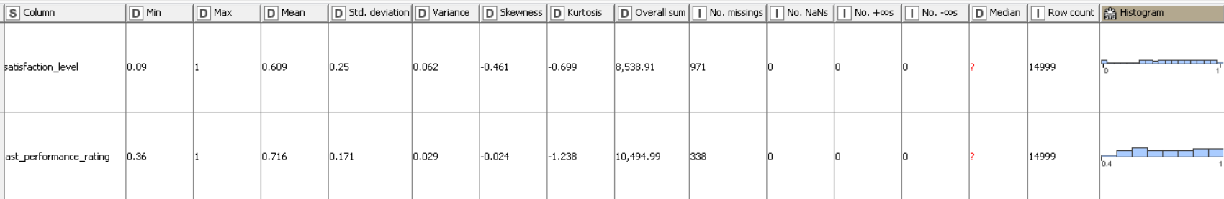
Figure 1: summary statistics.
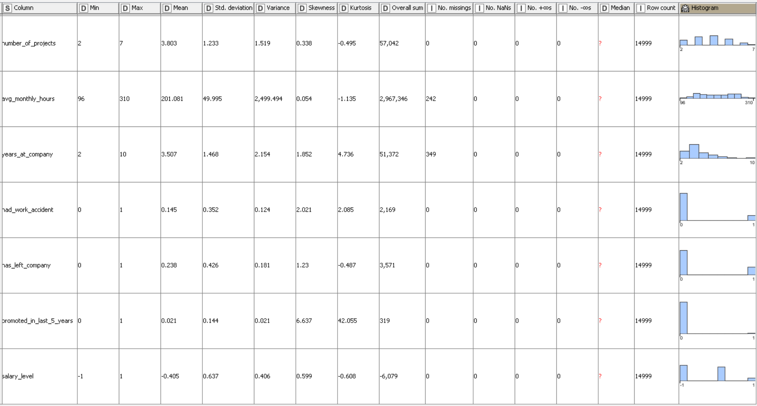
Figure 2: continuous of summary statistics

Table 2 shows the header of the first 5 samples we have with their variables, where the variables are shown in the columns. Figure 1 and Figure 2 shows a summary statistic about the data. satisfaction level ranges from 0.09 to 1, where 1 represents a 100% of satisfaction. Mean is 0.609 which indicates that the average satisfaction level is 60.9% and standard deviation is 0.25 which shows moderate variability around the mean. Skewness is -0.461 which is a slight left skew, this means that many employees have high satisfaction. The overall sum is 8,533.91.
Last performance ranges from 0.36 to 1. Mean is 0.716 or 71.6% and standard deviation is 0.171 which shows low variability in performance scores. Skewness is -0.024 which indicates an almost symmetric distribution. The overall sum is 10494.99. Number of Projects ranges from 2 to 7 projects per an employee. Mean is 3.803 and standard deviation is 1.233 moderate variability in project assignments. Skewness is 0.338 which is a slight right skew. The overall sum is 57042. Average monthly ranges from 96 to 310. Mean is 201.081 and standard deviation is 49.995 which shows high variability in monthly hours. Skewness is 0.054 which shows that the distribution is almost symmetric. The overall sum is 2967346. Years at comp ranges from 2 to 10. Mean is 3.507 and standard deviation is 1.468 which indicates moderate variability in tenure. Skewness is 1.852, which indicates a strong right skew. The overall sum is 51372. Had work accident ranges from 0 to 1. Mean is 0.145 and standard deviation is 0.352 which shows variability in accident occurrences. Skewness is 2.021 which is a strong right skew. The overall sum is 2169. Has left company ranges from 0 to 1. Mean is 0.238 which means 23.8% of employees left the company. Standard deviation is 0.426 which indicates some variability in turnover. Skewness is 1.23 which indicates a strong right skew that shows that most employees stay in the company. The overall sum is 3571 which means that there is a total of 3,571 employees left the company. Promoted in last 5 years ranges from 0 to 1. Mean is 0.021 which means that 2.1% of employees were promoted in the last 5 years. Standard deviation is 0.144 which indicates low variability. Skewness is 6.637 which shows a strong skew to the right. This means that promotions are rare. The overall sum is 319. Salary level ranges from -1 to 1. Mean is -0.405, which shows that most employees have a low salary. Standard deviation is 0.637, which means there is variability. Skewness is 0.599 that means there is a slight right skew. The overall sum is -6079.

3.3 Visualizations.
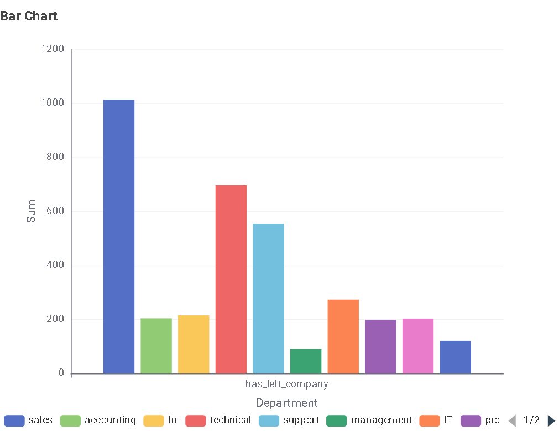

Figure 3: the total number of employee turnover within each department.
The bar chart, also known as column chart, in Figure 3 shows which department had the highest number of turnovers in the given dataset. It shows that the department with the highest number of employee turnovers was in sales department. On the other hand, management department has the lowest number of employee turnover.
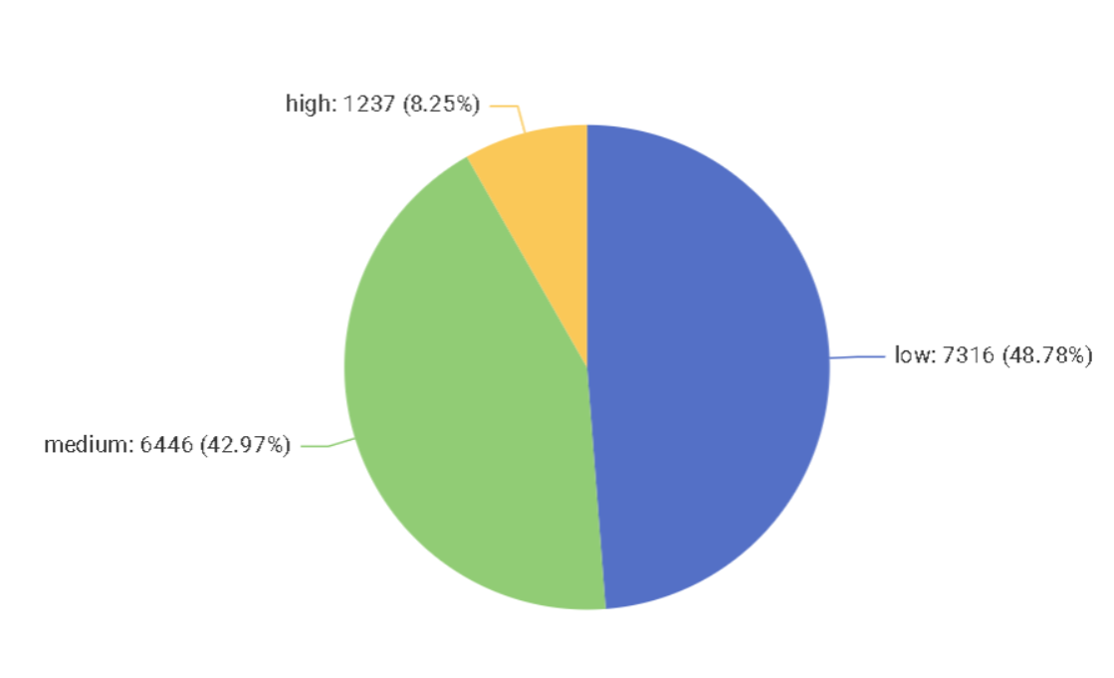
Figure 4: the percentage of people with high salaries, medium salaries, low salaries that we have in this dataset.
This pie chart, in Figure 4, divides the number of employees within this sample based on salary (high, medium, low). We can see that 1237 (8.25%) of the employees have high salary. The employees with medium salary are 6446 employees or 42.97% of the total number of employees. While the number of employees with low salary is 7316 employees (48.78%).

3.4 Missing data.
There was some missing data in numerical variables that was fixed by calculating the mean. For categorical variables, missing data were change into None to avoid any problems in KNIME nodes performance.

3.5 Correlation Analysis.
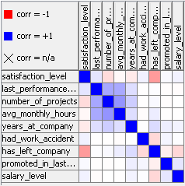
Figure 5: Correlation Matrix.

In this analysis, we are looking for the variables with the highest positive/negative correlations with the variable "has left company". As we can see, the variable "satisfaction level" shows the highest correlation score with "has left company" which is -0.39. This negative shows that the potential relationship between the employee's chance of leaving the company and his/her satisfaction level within the company is an inverse relationship. So, the less satisfied the employee is, the higher the chance of leaving the company would be.
There is a slight weak correlation between "has left company" and the two variables, "salary level" and "had work accident", separately. Both correlation scores are negative which means the potential relationship between "had left company" and "salary level" and the potential relationship between "has left company" and "had work accident" are inverse relationship, where both of them had correlation scores were -0.16. This means that the increment of salary level and the probability of having work accidents cause more cases of turnover (employees leaving the company).
On the other hand, the correlation score of "has left company" and "years at company" shows a Direct potential relationship, where the score was 0.14. This means that the longer the employee stays at the company, the less probability of leaving the company would be.

3.6 Structural Equation Modeling.
I applied Structural Equation Modeling (SEM) to the cleaned data. The dependent variables "has_left_company" is regressed on the independent variables that were introduced earlier.
Comparative Fit Index (CFI) = 1.000 (Perfect fit)
Tucker-Lewis Index (TLI) = 1.000 (Perfect fit)
Root Mean Square Error of Approximation (RMSEA) = 0.000 (Excellent fit)
Standardized Root Mean Square Residual (SRMR) = 0.000 (Excellent fit) the results show that the model is well fitted to the data, meaning that employee turnover can be explained very well by the chosen predictors.
In the SEM, the independent variables were:
-Satisfaction Level (β = -0.380, p < 0.001)
Employees with lower satisfaction tend to quit more. It's a strong predictor of attrition.
-Salary Level (β = -0.138, p < 0.001
Higher turnover goes with a low salary. Employees receiving higher salaries have a high chance of remaining in the organization.
Years at Company (β = 0.126, p < 0.001)
With longer years at company, the likelihood of leaving increases. This may indicate concerns about stagnation or career advancement.
Had Work Accident (β = -0.130, p < 0.001)
There is a slightly higher likelihood of employees leaving who have not had an accident at work. This may point to job security related to safety.
Number of Projects (β = -0.099, p < 0.001)
Employees handling fewer projects are more likely to leave. Probably, this is a matter of workload balance and engagement.
Average Monthly Hours (β = 0.072, p < 0.001)
Higher work hours increase the risk of attrition, which means burnout.
Performance Rating (β = 0.036, p < 0.001)
Higher ratings slightly increase turnover, suggesting that high performers may seek better opportunities.
Promotion in Last 5 Years (β = -0.042, p < 0.001)
Employees who have been promoted are less likely to quit, which suggests that career growth is an important reason.
Department β = 0.012, p = 0.107 Departmental differences are not a significant determinant of attrition.

Chapter 4: Methodology.
In this chapter, we will develop the methodology that we will use to reach this research’s objectives.

4.1 What are the types of analysis that will be used?
In this thesis, I will conduct several types of analysis that would allow us to understand the factors that effect on the employee turnover and predict the possibility of the employee turnover. We will use some visualizations such as bar chart, pie chart, and scatter plot to help us understand some of dependent variables and their relationship with the target variable, employee turnover. Then, we will conduct correlation analysis to understand the correlation between each of the dependent variables and our target variable. Afterwards, we will conduct logistic regression to predict the possibility of employee turnover. The coefficients of logistic regression model would help us understand which variables have the highest importance in predicting the employee turnover. Next, we will conduct random forest to predict the employee turnover. Then, I conducted Neural Network as a deep analysis technique to predict Employee Turnover. Then, I conducted Decision Tree model to predict Employee Turnover. Lastly, I conducted a more advanced technique that was not chosen based on the techniques table in chapter 2. It is Logistic Regression based on K-means. This last model was made to try and enhance logistic regression accuracy. Then, all models’ performance would be compared using accuracy as the validation method to choose the best model in predicting employee turnover.
4.2 Decision Tree.
A classification decision tree is induced in main memory by this model. While the other attributes used to make decisions can be either numerical or nominal, the target attribute needs to be nominal. The domain is divided into two partitions at a specified split point using numerical splits, which are always binary. Nominal splits can be either binary or multi-way; multi-way splits provide as many outcomes as nominal values, whereas binary splits split nominal values into two categories. The Gini index and the gain ratio are the two quality metrics that the algorithm employs for split computation. In order to decrease tree size and improve prediction accuracy, a post-pruning technique founded on the minimum description length principle is also used. The model can effectively use several processors or cores because it can execute in numerous threads [133].

4.3 Logistic regression.
Logistic Regression or Logit Regression is one of the most common methods in classification analysis. It predicts the probability of a sample being in or under a particular class. For example, it can classify whether an email is spam or not. This model calculates a weighted sum of the input features then it adds a bias term to apply a logistic function. The probability that results of that is the result that this model is expected to give. The goal in the training stage of this model is to adjust the model’s parameters, which would assign high probabilities to correct classifications and low probabilities to incorrect ones. The class probabilities that logistic regression provides make it more reliable and versatile in real-world applications. Logistic regression is considered to be a fundamental tool in statistics and machine learning [130].
${Log}_{e}\left[\frac{P(Y=1|X_{1},…,X_{p})}{1-P(Y=1|X_{1},…,X_{p})}\right]={Log}_{e}\left[\frac{π}{1-π}\right]=α+β_{1}X_{1}+…+β_{p}X_{p}=α+\sum_{j-1}^{p}{β_{j}X_{j}}$ [137]
This equation expresses the log-odds (logit function) of the probability that Y = 1 given the predictors [137].
1. Y: The dependent (binary) variable, which can take values 0 or 1 [137].
2. P(Y=1|X₁, ..., X_{p}) (denoted as π): The probability that Y takes the value 1 given the predictors X1, ..., X_{p}. P(Y=1 X₁,...,X_{p}) [137].
3. 1-P(Y=1 X1,X): This is called the odds of X_{p} Y = 1. It represents the ratio of the probability of success (Y = 1) to the probability of failure (Y = 0) [137].
4. loge (natural logarithm of odds, also called the logit function): Converts the probability into an unbounded scale to allow for linear modelling [137].
5. a: The intercept term, representing the baseline log-odds when all predictor variables are zero [137].
6. β_{j} (for j = 1, 2, ..., p): The coefficients associated with each predictor variable X_{j}. Each B_{j} represents the change in log-odds for a one-unit increase in X_{j}, holding other variables constant [137].
7. X_{j} (for j = 1, 2, ..., p): Independent variables (predictors) that influence Y [137].
8. Σ=1 β_{j}X_{j}: The summation notation P representing the linear combination of all predictor variables and their corresponding coefficients [137].
The left-hand side of the equation is the log-odds of the probability of Y = 1[137].
The right-hand side is a linear combination of predictors [137].
The logistic function, obtained by exponentiating both sides, maps any real-valued input to the range (0,1), ensuring valid probability outputs [137].

4.4 Random Forest.
Random Forest is considered to be one of the most powerful machine learning algorithms, where it is used for both classification and regression tasks. The operation of this model works by building multiple decision trees in the training stage and combines their outputs to make more accurate and robust predictions. Each tree is trained on a random subset of the data and features. This operation that random forest has, reduces overfitting and improves generalization. Averaging the results for regression tasks or using a majority vote for classification problems gives the final prediction that we are seeking. This model is considered to be valuable because of its ability to handle large datasets with keeping high dimensionality. It is also valuable because of its ability to resist noise. It also helps users in understanding which variables have the most influence on the prediction result by providing us with insights about feature importance. This algorithm is widely used in many applications because of its reliability, scalability, and ease of use [130].

A random forest made up of a predetermined number of decision trees is trained by this model. Every decision tree has the same size as the initial input dataset, is constructed using a distinct selection of rows, and is produced by bootstrapping. A randomly chosen subset of attributes is used for every split inside a tree. This is achieved by choosing sqrt(m) attributes from the total number of learning columns, where m is the number of input attributes. A variety of attribute forms, such as bit (fingerprint), byte, or double vector, are supported by the model. Prediction can be made using the random forest that is produced [134].

4.5 Neural Network.
This model trains a Probabilistic Neural Network (PNN) using the Dynamic Decay Adjustment (DDA) method on labeled data, following the Constructive Training of Probabilistic Neural Networks algorithm. It uses numerical data to construct rules, each of which is represented by a high-dimensional Gaussian function. Two thresholds, theta minus and theta plus, are used to modify these functions in order to avoid clashing with rules from other classes. A center vector from the first covered instance and a standard deviation that is adjusted during training to cover only non-conflicting examples define each Gaussian function. Additional columns are utilized as classification goals, and the chosen numerical columns from the input data are used as training input. A single column with class information or several numeric columns with class degrees ranging from 0 to 1 can serve as the classification objective. The model generates a set of rules and different rule metrics after it has been run. This model predicts by matching each sample data with the best match rules and decides whether it is 1 or 0 for the binary target variable [135].

4.6 K-Means.
This model finds cluster centers for a predetermined number of clusters Without dynamically changing the number of clusters. Crisp clustering is carried out by K-means, which allocates each data vector to a single cluster. Cluster assignments are iterated till they don't change. It clusters the chosen properties using the Euclidean distance metric [136].

4.7 The workflow on KNIME for the expletory analysis and models.

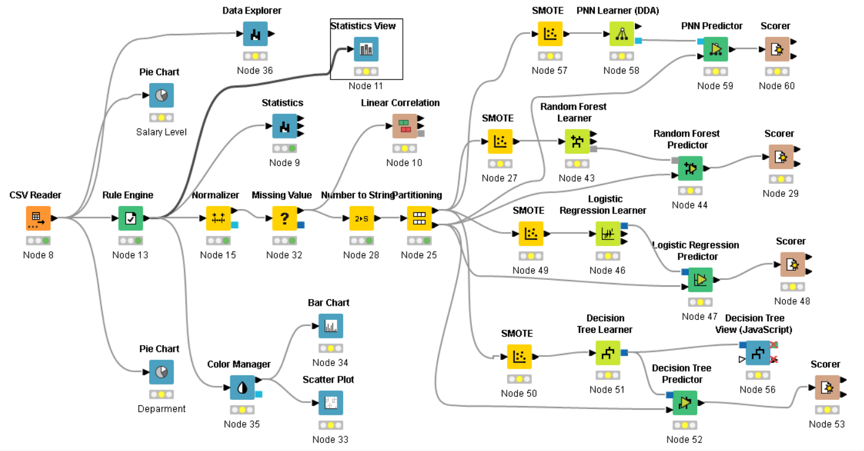
Figure 6: Workflow on KNIME.
This project was done on KNIME. Figure 6 show the workflow that was done on KNIME. The first step was using Rule Engine node to convert the values of “left” from yes or no into 0 for no and 1 for yes. Then, Statistics node, pie chart node, Colour manager, bar chart, and scatter plot were used for visualisations. For the analytics of logistic regression, random forest, and linear correlation, the steps on KNIME were going as follows:
1-Excel reader node for reading the excel file.
2-Rule Engine for changing the values of “left” as it was mentioned before.
3-Normalizer for normalizing all numerical variables to make them range from 0 to 1 and to increase the accuracy of the upcoming analytics.
4-Missing value node for fixing missing values by using the mean for numerical variables and for replacing missing values of categorical variables into None.
-Linear Correlation node: this node comes after treating missing values where correlation needs “left” variable to be numerical. So Linear correlation was conducted, and the results was shown previously.
5-Number to String node for converting “left” values into Categorical variables.
6-partitiining for partitioning the data by making part 1 (70%) for training models and part 2 (30%) for testing the models. The partitioning was done by stratified method based on “left”
-here the workflow divides into 2 parts where the first part is building Random Forrest model while second part is building Logistic Regression model.
7-SMOTE node is used twice, once for each model to fix the problem of imbalance within the data whereas we saw previously on the histograms, the data based on “left” variable is imbalanced data.
8-Random Forrest Learner node was applied on the 70% part to train the model of Random Forrest to predict whether the employee would leave the company or not.
9-Random Forrest Predictor was applied on the 30% testing part that we got from the partitioning and the model that Learner node made was transformed into it to test the data.
10-Scorer node was used to compare the results of prediction of the 30% testing part with the actual results of the 30% testing part. It shows the accuracy of the model’s prediction and the confusion matrix.
11-Logistic Regression Learner for applied on the 70% part to train the model of Logistic Regression to predict whether the employee would leave the company or not.
12-Logistic Regression Predictor was applied on the 30% testing part that we got from the partitioning and the model that Learner node made was transformed into it to test the data.
13-Scorer node was used to compare the results of prediction of the 30% testing part with the actual results of the 30% testing part. It shows the accuracy of the model’s prediction and the confusion matrix.
14- PNN (Probabilistic Neural Network) model branch:
Third modeling direction was developed using a Probabilistic Neural Network (PNN) following the division of the dataset. For class imbalance in training data handling, SMOTE node (used in the same manner as the previous models) was used before model training.
The PNN Learner (DDA) node was then used to build the PNN model. This learner node uses a memory-based technique of classification according to the probability density estimation and distance measurement in a multidimensional space. Having trained the model on the 70% training partition, the model was then fed into the PNN Predictor node, which made predictions on the 30% test partition using the model.
Finally, the Scorer node was used to evaluate the predicted values against the actual class labels of the test partition. Like the other model branches, this node provides evaluation metrics such as accuracy, precision, recall, and the confusion matrix to ascertain the predictive performance of the model.

15- Decision Tree model branch:
The second branch was also developed with a Decision Tree algorithm as a base model. Like the earlier branches, SMOTE was employed first on the 70% training dataset for addressing class imbalance.
The Decision Tree Learner node was then used to build a classification tree using the training information. The model was sent to the decision Tree Predictor node, where it was applied to the 30% test partition so predictions were generated.
The resulting tree structure was then presented through the Decision Tree View (JavaScript) node, which presented an interactive decision tree that made it easy to interpret how the model makes decisions at each split.
Finally, the Scorer node was utilized again to compare predicted values against actual test labels in determining the predictive power of the Decision Tree model.

For deployment, we used model writer node and for some models that model writer node doesn't apply for, we used a different deployment node to write the models (and deploy them).

T setting of portioning node on KNIME was to partition the data into training data and testing data. The dataset was splinted into 2 parts, first part is 70% which is for training the model while second part is 30% which is used for testing the model. With "has_left_company" as the stratification variable, stratified sampling is activated. This guarantees that in both partitions, the percentages of the various groups in this column (employees who departed against those who stayed) stay the same. This is essential to preserving the dataset's class balance and avoiding model bias.

“The SMOTE node in KNIME performs oversampling of the minority class on the training data. It allows users to choose the number of nearest neighbours and whether to oversample the minority class only or each class equally12. The technique used is called SMOTE (Synthetic Minority Over-sampling Technique) by Chawla et al” [132]. This is the settings of STOME node on KNIME to fix the problem of imbalanced data that the statistics of “has_left_company” variable show in the statistics section. SMOTE node works by considering the nearest 5 neighbours for each sample for the variable “has_left_company” and oversampling minority classes.

4.8 Logistic regression based on k-means on KNIME.

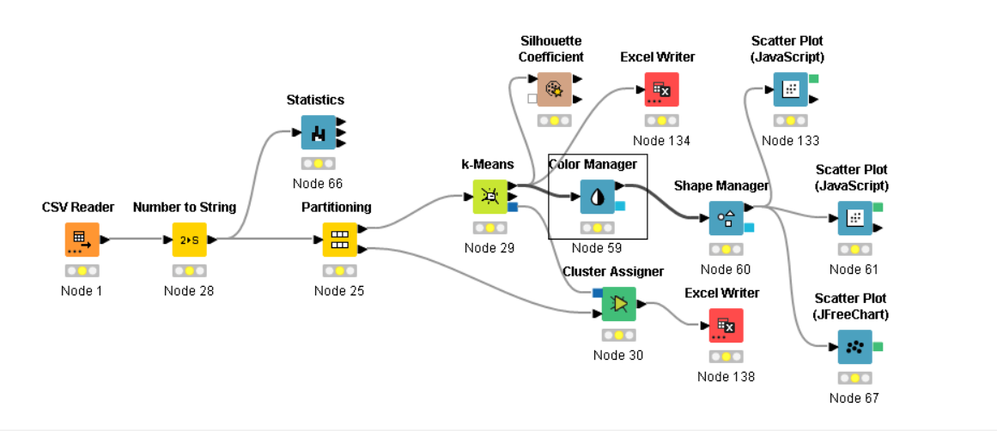
Figure 7: KNIME workflow of performing K-Means.
In this step, I used the HR dataset in KNIME to perform clustering analysis using the k-Means algorithm. Here is a step-by-step description of what I did:
Data Import and Preprocessing
I started with loading a CSV file using the CSV Reader (Node 1). Since certain numerical values needed to be transformed into categorical variables, I utilized a Number to String (Node 28) conversion. Subsequently, I utilized Partitioning (Node 25) for splitting the dataset into training and test sets.
Exploratory Data Analysis
To gain some insight into the dataset, I used the Statistics (Node 66) utility to get the summary statistics.
Clustering with k-Means
I utilized the k-Means (Node 29) algorithm to cluster the data into clusters based on similarities. Once the clusters were assigned, I utilized the Cluster Assigner (Node 30) to label every data point with its corresponding cluster.
Visualization and Evaluation
To make the clustering results more understandable, I applied the Color Manager (Node 59) and Shape Manager (Node 60) to distinguish the clusters visually. Additionally, I plotted some scatter plots using Scatter Plot (JavaScript) (Nodes 133 & 61) and Scatter Plot (JFreeChart) (Node 67) to visualize the clusters. For cluster quality testing, I computed the Silhouette Coefficient (Node 13).
Exporting the Results
Finally, I stored the grouped data using Excel Writer (Nodes 134 & 138) for reporting or further analysis.
Through this procedure, I managed to organize similar data points into significant groups, evaluate cluster performance, and plot the result for better insight.

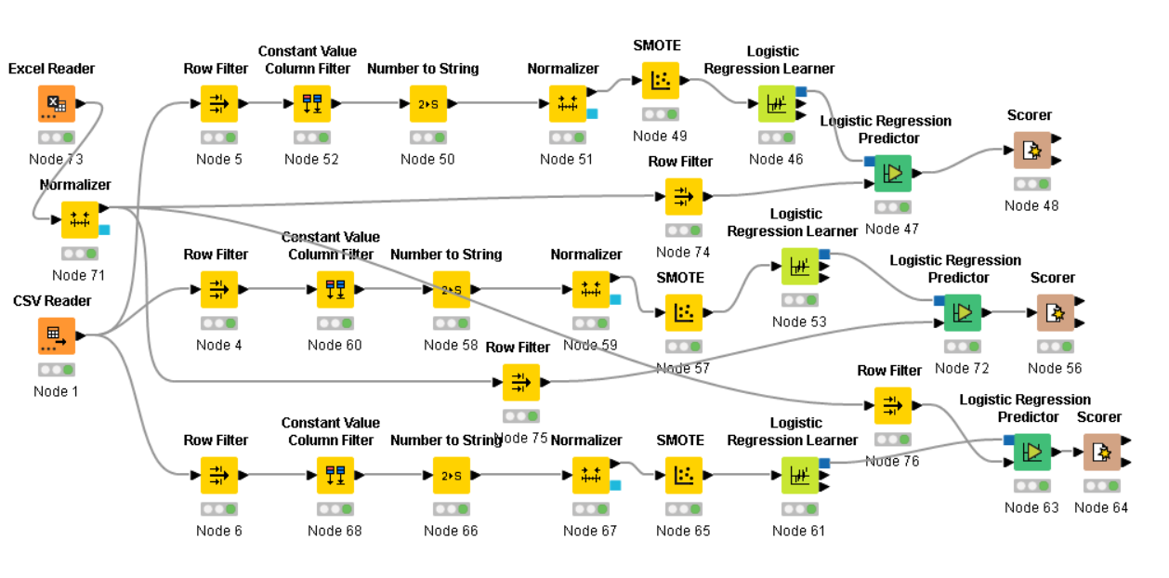
Figure 8: KNIME workflow of performing Logistic Regression based on K-Means.
I designed a KNIME workflow to perform logistic regression using the result of a K-Means clustering analysis. The key steps in the workflow are:
Data Input (CSV Reader - Node 1): The data are read by the CSV Reader node to be used on the workflow. The data was called by Node 1 was the trained data that K-Means was performed on where this data does not include the testing data. The testing data would be recalled later. This ensures having the same training and testing data for all models.
Preprocessing:
Row Filtering (Nodes 4, 5, etc.): The data was filtered based on the column “cluster” that resulted from k-means model where Node 5 excluded cluster 1 and 2 to maintain only cluster 0 in the model, Node 4 filtered cluster 0 and cluster 2 to maintain only cluster 1, and Node in the lowest line excluded cluster 0 and 1 to maintain only cluster 2 in the model.
Constant Value Column Filter (Nodes 52, 60, etc.): Some constant-value columns are removed to prevent redundancy.
Number to String Conversion (Nodes 50, 58, etc.): Some categorical data is kept in the appropriate format.
Normalization (Nodes 51, 59, etc.): Numerical values are converted into the appropriate range for improved model performance.
Handling Class Imbalance (SMOTE Nodes): The Synthetic Minority Over-sampling Technique (SMOTE) is applied to balance the data by generating synthetic samples for the minority class.
CSV Reader Node 69: This node is calling the testing data that was portioned in the previous workflow that was shown earlier. This was done to ensure that the testing data that was used in all models are the same to maintain a fair comparison of models.
Testing Data Splitting (Partitioning Nodes): The data are split into training and test sets for model performance evaluation.
Model Training (Logistic Regression Learner - Nodes 53, 74)
The logistic regression model is trained on partitioned and prepared data.
Model Prediction & Evaluation:
Logistic Regression Predictor (Nodes 47, 72, etc.): Provides predictions on the basis of the trained model. Scorer (Nodes 48, 56, etc.): Validates the performance of the model by comparing predictions to actual values.
This workflow overall makes it possible for proper usage of logistic regression while ensuring data quality through preprocessing, handling class imbalance, and appropriate model validation.

4.9 Portioning 60%-40% and 80%-20%.
To make sure that the portioning percentage is not playing a role in model comparison of which model is the most accurate in predicting employee turnover, I portioned the dataset in other different ways. I used the same workflows shown previously but once with portioning dataset as 60% for training the models and 40% for testing the models, and second time with portioning the dataset as 80% for training models and 20% for testing the models. All of the settings within workflows is the same as it was explained earlier.

Chapter 5: Results.

5.1 Logistic Regression results.
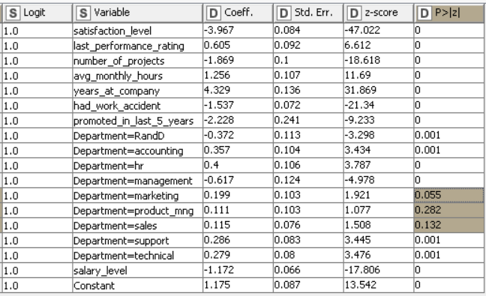
Figure 9: Coefficients of the variables of logistic regression model.
Figure 9 shows the coefficients of logistic regression model. The departments marketing, product management, and sales have p-value less than 0.05. We will exclude these variables in the logistic regression. The coefficients show the most important variables based on logistic regression model, where the variables with higher coefficients have higher importance in the model building. As we can see, the number of years at company is the most important variable in this model where it has coefficient of 4.329.
Table 3: Confusion Matrix.
 | 1.0 | 0.0
1.0 | 885 | 828
0.0 | 186 | 2601

Table 4: Accuracy scores.
Row ID | True Positives | False Positives | True Negatives | False Negatives | Recall | Precision | sensitivity | Specificity | F-measure | Accuracy
1.0 | 885 | 186 | 2601 | 828 | 0.517 | 0.826 | 0.517 | 0.933 | 0.636 | ?
0.0 | 2601 | 828 | 885 | 186 | 0.933 | 0.759 | 0.933 | 0.517 | 0.837 | ?
Overall | ? | ? | ? | ? | ? | ? | ? | ? | ? | 0.775
Tables 3 and 4 show the results of employee turnover prediction on the 30% test data. After training the logistic regression model on the training data (70% training part) and testing its accuracy of predicting the employees that would leave the company on the testing part (30% testing part), we can see that the model was able to predict 77.5% of the testing data correctly. This accuracy percentage is very low comparing to the random forest model.

5.2 Random Forest results.
In this Random Forest configuration, we have included several key features such as satisfaction_level, last_performance_rating, number_of_projects, avg_monthly_hours, years_at_company, had_work_accident, promoted_in_last_5_years, and Department while ensuring no columns are excluded. In order to help the model determine the optimal splits, the split criterion is set to the Gini Index, which gauges a node's impurity. To avoid overfitting and unnecessary complexity, we have restricted the tree depth to a maximum of 12 levels. Additionally, we have enforced a minimum node size of 5 to guarantee that each leaf node has a sufficient number of samples. 200 trees are used to train the model, balancing computational cost and performance. To keep our results reproducible, we have also made it possible to use a static random seed. To maximize memory use, several features like highlighting patterns and storing the target distribution in tree nodes are left deactivated.

Table 5: Confusion Matrix 2.
Row ID | 1.0 | 0.0
1.0 | 1013 | 58
0.0 | 24 | 3405

Table 6: Accuracy Scores 2.
Row ID | True Positives | False Positives | True Negatives | False Negatives | Recall | Precision | sensitivity | Specificity | F-measure | Accuracy
1.0 | 1013 | 24 | 3405 | 58 | 0.946 | 0.977 | 0.946 | 0.993 | 0.961 | ?
0.0 | 3405 | 58 | 1013 | 24 | 0.993 | 0.983 | 0.993 | 0.946 | 0.988 | ?
Overall | ? | ? | ? | ? | ? | ? | ? | ? | ? | 0.982

Tables 5 and 6 show the results of employee turnover prediction of random forest model that was conducted on the 30% testing data as we can see in the confusion matrix results of the prediction of the employees that might leave the company, the random forest model was able to predict 98.2% of the test data correctly.

5.3 K-Means.
Table 6: Finding optimal k using Overall Silhouette Coefficients.
K | Overall Silhouette Coefficient
2 | 0.316
3 | 0.43
4 | 0.428
5 | 0.418
6 | 0.402
7 | 0.424
8 | 0.407
9 | 0.398
10 | 0.409
11 | 0.392
12 | 0.415
13 | 0.416
14 | 0.412
15 | 0.404

The clustering was based on satisfaction level, years at company, had work accident, salary level. These variables were chosen because they were the variables with the most correlation score as we saw previously in correlation analysis results. The number of clusters (k) was chosen where I performed k-means first with selecting k = 2 or 2 clusters and measured how good the clusters are by using silhouette coefficients. K=2 gave an overall mean silhouette coefficient of 0.316. Then, I performed the k-means again but with selecting k = 3 or 3 clusters this time. The overall mean silhouette coefficient was 0.430, which is higher than k = 2. Then, I performed k-means with K=4 or 4 clusters. The overall mean silhouette coefficient was 0.428, which is less than the overal mean silhouette coefficient of k = 3. Continuing the comparison of ks from k = 2 to k = 15 as we see in the Table, k = 3 has the highest overall silhouette coefficient which makes it the optimal k for ks from k = 2 to k = 15.
After selecting k = 3 (the optimal number of clusters), I'll report the centroids of the 3 clusters obtained. The 10,499 samples were divided as following:
Cluster 0 has 1,525 samples
Cluster 1 has 4,381 samples
Cluster 2 has 4,593 samples
The centroids for cluster 0, 1, and 2 are going to be represented as follows:
(satisfaction level, years at company, had work accident, salary level)
Cluster 0: (0.612, 0.191, 1, 0.306)
Cluster 1: (0.551, 0.181, 0, 0)
Cluster 2: (0.572, 0.194, 0, 0.58)

5.4 Decision Tree.

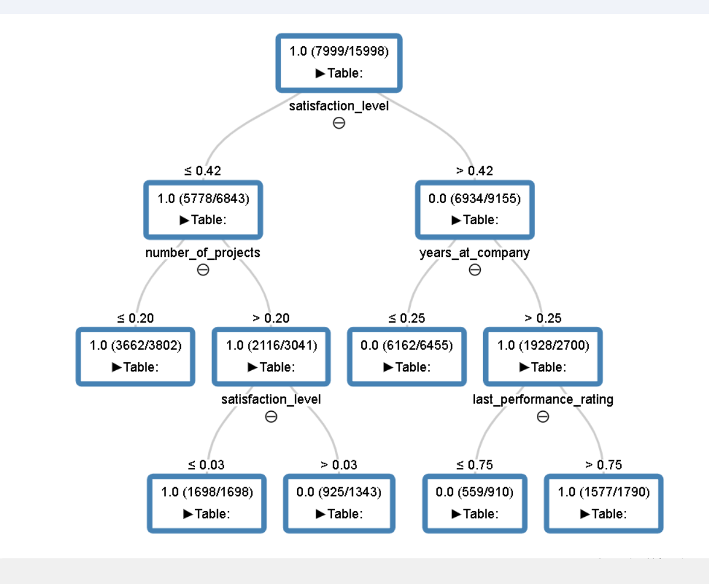
Figure 10: Decision Tree Model.
The data was portioned as 70% for training the decision tree model and 30% for testing the model. Figure 10 shows the model of decision tree. NPL was used as pruning method to avoid overfitting in the model. As we see in the Figure, decision tree model was trained on the 70% on KNIME platform and the model chosen the best features using Gimi index. Then, the 30% part of data was used to test the model. This decision tree visualization represents how the model makes predictions based on different features. The root node starts with satisfaction_level, splitting at a threshold of 0.42. If satisfaction_level is less than or equal to 0.42, the model moves to number_of_projects, which is further split at 0.20. If the number of projects is below this threshold, the model predicts 1.0 (left the company) with a high proportion of samples. If greater than 0.20, the model considers satisfaction_level again, splitting at 0.03, where lower values strongly indicate an employee leaving. On the other hand, if satisfaction_level is greater than 0.42, the model moves to years_at_company, splitting at 0.25. Employees with fewer years at the company tend to stay (0.0), while those with more experience are more likely to leave (1.0). Further down, last_performance_rating is considered, with a threshold of 0.75. Employees with lower ratings (≤0.75) are more likely to stay, while those with higher ratings (>0.75) have a higher chance of leaving. This tree structure provides insight into the key factors influencing employee attrition and helps identify patterns in employee turnover.
Table7: confusion matrix of decision tree.
Row ID | 1.0 | 0.0
1.0 | 955 | 122
0.0 | 116 | 3307

Table 8: Accuracy table.
Row ID | True Positives | False Positives | True Negatives | False Negatives | Recall | Precision | sensitivity | Specificity | F-measure | Accuracy
1.0 | 955 | 116 | 3307 | 122 | 0.887 | 0.892 | 0.887 | 0.966 | 0.889 | ?
0.0 | 3307 | 122 | 955 | 116 | 0.966 | 0.964 | 0.966 | 0.887 | 0.965 | ?
Overall | ? | ? | ? | ? | ? | ? | ? | ? | ? | 0.947

Tables 7 and 8 show the results of employee turnover prediction on the 30% test data. After training the decision tree model on the training data (70% training part) and testing its accuracy of predicting the employees that would leave the company on the testing part (30% testing part), we can see that the model was able to predict 94.7% of the testing data correctly. This accuracy is lower than random forest model but it is higher than logistic regression model.

5.5 Neural Network.
In the neural network model, the option “shrink after commit” was enables to optimize or compress the model structure after committing updates during the training stage. The option “use class with max coverage” was enabled too to prioritize the class with the highest representation in cases where there is uncertainty.
Table 9: Confusion Matrix.
Row ID | 1.0 | 0.0
1.0 | 898 | 173
0.0 | 33 | 3396

Table 10: Accuracy Table.
Row ID | True Positives | False Positives | True Negatives | False Negatives | Recall | Precision | Sensitivity | Specificity | F-measure | Accuracy
1.0 | 898 | 33 | 3396 | 173 | 0.838 | 0.965 | 0.838 | 0.99 | 0.897 | ?
0.0 | 3396 | 173 | 898 | 33 | 0.99 | 0.952 | 0.99 | 0.838 | 0.971 | ?
Overall | ? | ? | ? | ? | ? | ? | ? | ? | ? | 0.954

Tables show the results of employee turnover prediction on the 30% test data. After training the Neural Network model on the training data (70% training part) and testing its accuracy of predicting the employees that would leave the company on the testing part (30% testing part), we can see that the model was able to predict 95.4% of the testing data correctly. This accuracy percentage is higher than decision tree and logistic regression, but it is lower than random forest model accuracy.

5.6 Logistic Regression based on K-Means Results.
The results of each one of the 3 models based on clusters 0, 1, and 2.
Cluster 0:
Table 11: Confusion Table.
Row ID | 1.0 | 0.0
1.0 | 472 | 382
0.0 | 139 | 896

Table 12: Accuracy Table.
Row ID | True Positives | False Positives | True Negatives | False Negatives | Recall | Precision | Sensitivity | Specificity | F-measure | Accuracy
1.0 | 472 | 139 | 896 | 382 | 0.553 | 0.773 | 0.553 | 0.866 | 0.644 | ?
0.0 | 896 | 382 | 472 | 139 | 0.866 | 0.701 | 0.866 | 0.553 | 0.775 | ?
Overall | ? | ? | ? | ? | ? | ? | ? | ? | ? | 0.724

Cluster 1
Table 13: Confusion Matrix.
Row ID | 1.0 | 0.0
1.0 | 37 | 171
0.0 | 15 | 398

Table 14: Accuracy Table.
Row ID | True Positives | False Positives | True Negatives | False Negatives | Recall | Precision | Sensitivity | Specificity | F-measure | Accuracy
1.0 | 37 | 15 | 398 | 171 | 0.178 | 0.712 | 0.178 | 0.964 | 0.285 | ?
0.0 | 398 | 171 | 37 | 15 | 0.964 | 0.699 | 0.964 | 0.178 | 0.811 | ?
Overall | ? | ? | ? | ? | ? | ? | ? | ? | ? | 0.7

Cluster 2
Table 15: Confusion Matrix.
Row ID | 1.0 | 0.0
1.0 | 216 | 230
0.0 | 192 | 1352

Table 16: Accuracy Table.
Row ID | True Positives | False Positives | True Negatives | False Negatives | Recall | Precision | Sensitivity | Specificity | F-measure | Accuracy
1.0 | 216 | 192 | 1352 | 230 | 0.484 | 0.529 | 0.484 | 0.876 | 0.506 | ?
0.0 | 1352 | 230 | 216 | 192 | 0.876 | 0.855 | 0.876 | 0.484 | 0.865 | ?
Overall | ? | ? | ? | ? | ? | ? | ? | ? | ? | 0.788

The sum up of all 3 confusion matrix to evaluate the final accuracy of all 3 models of logistic regression that was smarmier by k-means:
Table 17: Confusion Matrix of Summing All Confusion Matrixes of 3 Clusters.
Row ID | 1.0 | 0.0
1.0 | 725 | 783
0.0 | 346 | 2646

Tables show the results of employee turnover prediction on the 30% test data. After training the logistic regression models based on k-means segmentation on the training data (70% training part) and testing its accuracy of predicting the employees that would leave the company on the testing part (30% testing part), we can see that the model was able to predict (725+2646)/(725+2646+783+346)=74.9% of the testing data correctly. This accuracy percentage is the lowest of all models which indicates that the testing data might need to be assigned to the clusters before being tested by the logistic regression models.

5.7 Models Comparison.
Table 18: Models’ Accuracy of the 30% testing data.
Model Name | Accuracy
Logistic Regression | 77.50%
Random Forest | 98.20%
Decision Tree | 94.70%
Neural Network | 95.40%
Logistic Regression based on K-Means | 74.90%

Comparing all Models, we can see that Random Forest had the highest Accuracy in predicting Employee Turnover. We also can see that Neural Network is the best model in predicting Employee Turnover. The third best model was Decision Tree, the Random Forest performed better than decision tree because Random Forest is technically a multiple Decision tree models. The Logistic Regression model, both in the original technique and in the advanced technique based on K-Means, had the worst performance in predicting Employee Turnover.
Table 19: Models’ Accuracy of the 40% testing data.
Model Name | Accuracy
Logistic Regression | 76.2%
Random Forest | 97.6%
Decision Tree | 93.8%
Neural Network | 94.9%

Table 20: Models’ Accuracy of the 20% testing data.
Model Name | Accuracy
Logistic Regression | 77%
Random Forest | 97.8%
Decision Tree | 94.1%
Neural Network | 94.9%

Table 19 and 20 show that the order of which model is the best in predicting employee turnover didn’t change, where Random Forest is still the most accurate model in predicting employee turnover. This shows that changing the portioning from 70% for training models and 30% for testing them into other partitioning is not a factor that plays a role in deciding which model performs the best in prediction.

Chapter 6: Conclusion.
Throughout this thesis, we performed several analysis methods to investigate employee turnover factors and used some different machine learning models to predict employee turnover probabilities. This chapter provides a summary of major findings, model performances comparison, and implications and future work.

6.1 Summary of Findings.
Applying exploratory data analysis (EDA), we had an understanding of top independent variables that might influence employee turnover. These variables were years at company, satisfaction level, work accidents, and salary level. Visualizations such as bar chart, pie chart, and scatter plot provided us with an understanding of data distribution and independent variables with respect to the target variable, employee turnover.
Correlation analysis revealed that certain variables such as years at company and satisfaction level had the most significant correlation score with employee turnover. This insight guided us in the step of selecting feature variables for models such as k-means.
we implemented and compared four machine learning models that we developed on KNIME platform: decision tree, logistic regression, random forest, logistic regression based on k-means, and neural network. Each model provided different insights and predictive accuracies:
Logistic Regression: This model yielded the most significant variables that affect turnover. The years at company variable had the largest coefficient number, indicating that it had the largest effect on target variable, employee turnover. However, the model was only 77.5% accurate, which is lower than the other models. This model is the fourth best model in predicting employee turnover out of 5 models.
Random Forest: This model was the best model in prediction with a 98.2% accuracy. The ability of the model to detect non-linearity and interaction among variables made it the most efficient. This model has the best performance in predicting employee turnover among all models.
Decision Tree: It possessed accuracy higher than Logistic Regression but lower than Random Forest of 94.7% and also presented an explicit, interpretable structure to understand decision points leading to employee turnover. Pruning strategies were used to prevent overfitting and enhance generalizability. This model was the third-best model in prediction.
K-Means Clustering: Through analysis by silhouette coefficient, we observed that three groups (k = 3) provided the optimum separation of employees based on Silhouette Scores that we saw in chapter 5, according to their satisfaction level, years of work at the company, having a work accident, and salary level. This unsupervised technique identified differentiated employee groups, which can be useful in targeted retention activities.
Logistic Regression based on K-Means Clustering: this model was an idea that we tried out to enhance logistic regression accuracy by first conducting k-means results and perform logistic regression model on each cluster to lessen the range of each of the most independent variable that logistic regression deals with while predicting employee turnover. This idea failed, where it had the worst accuracy score of 74.9%. A possible reason of this model’s failure is that testing data for each cluster is not 70%-30% for each cluster because only the total training data and testing data are 70%-30%. This model turned out had the worst model’s accuracy in predicting employee turnover.
Neural Network: this model is a deep analysis that we conducted in the predictive analysis. this model turned out to be the second-best model in predicting employee turnover with an accuracy score of 95.4%.

6.2 Implications
The findings of this research have human resource management practical implications. Determination of the strongest predictors of employee turnover enables companies to make evidence-backed policies to support the retention of employees. For example,
Targeted Retention Programs. Addressing drivers like low satisfaction and work-life balance can reduce turnover risk among high-risk employees.

Early Identification: Predictive models can be applied to at-risk employees, allowing early outreach and policy interventions.

Data-Driven Decision-Making: Empirical results from machine learning models are utilized in informing HR policy, optimizing resource allocation, and improving workforce stability.

6.3 Limitations
Although this research offers revealing conclusions, some limitations should be noted:
Feature Scope: The study was limited to specific variables in the dataset. There are some other unmeasured variables (e.g., individual-level causes, organizational causes) that have a potential influence on turnover too.
Generalizability of Model: The models are learned across one dataset and would have differing accuracy when they are tested across different industries or organizational settings.

6.4 Future Work
There are several alternative ways in which the work may be continued in the future:
Advanced Modeling Methods: Investigating deep learning methods or ensemble techniques can enhance predictive performance even more.
Expanded Feature Sets: Incorporating additional variables such as employee opinions, performance scores, and outside labour market pressures can increase the model.
Longitudinal Analysis: Analyzing employee turnover over a span of time might see fluctuating patterns and give more feedback to long-term retention initiatives.
Real-Time Forecasting Systems: Developing computerized systems that monitor and predict employee turnover in real-time could enable ongoing HR decision-making.

6.5 Conclusion
In general, this research was able to utilize machine learning models to predict and forecast employee turnover. Of the models employed, random forest and neural network models performed best with high accuracy, and they were good tools for predicting the risk of employee turnover. The results of this analysis can be applied by organizations to develop effective retention strategies, thereby reducing turnover and ensuring workforce stability. Subsequent studies would then be able to expand on these findings with additional features and more advanced modeling techniques, further enhancing the ability to predict and explain employee behaviour.

References
109. Aditchere, J., & Angmortey, R. (2024). The Roles of Relational Leadership and Employee Satisfaction in the Linkage Between Social Capital and Employee Turnover: A Moderated-Mediation Analysis. Authorea Preprints.‏
91. Ahmad, N., Ahmad, A., & Ashfaq, B. (2021). Islamic Work Ethics and Employees’ Turnover Intention: Modeling the Intrinsic Motivation as a Mediator. Pakistan Social Sciences Review, 5, 650-666.‏
78. Al Balushi, A. K., Thumiki, V. R. R., Nawaz, N., Jurcic, A., & Gajenderan, V. (2022). Role of organizational commitment in career growth and turnover intention in public sector of Oman. Plos one, 17(5), e0265535.‏
27. Al-Dalahmeh, M. L., Héder, M., & Dajnoki, K. (2020). The effect of talent management practices on employee turnover intention in the information and communication technologies (ICTs) sector: Case of Jordan.‏
15. Ali, B. J., & Anwar, G. (2021). Employee turnover intention and job satisfaction. International Journal of Advanced Engineering, Management and Science, 7(6), 22-30.‏
43. Al-Maaitah, D. A. A., Al-Maaitah, T. A. M., & Alkharabsheh, O. H. M. (2021). The impact of job satisfaction on the employees turnover intention at public universities (Northern Border University). International Journal of Advanced and Applied Sciences, 8(5), 53-58.‏
5. Al-Suraihi, W. A., Samikon, S. A., Al-Suraihi, A. H. A., & Ibrahim, I. (2021). Employee turnover: Causes, importance and retention strategies. European Journal of Business and Management Research, 6(3), 1-10.‏
106. Alterman, V., Bamberger, P. A., Wang, M., Koopmann, J., Belogolovsky, E., & Shi, J. (2021). Best not to know: Pay secrecy, employee voluntary turnover, and the conditioning effect of distributive justice. Academy of Management Journal, 64(2), 482-508.‏
44. Amankwaa, A., Seet, P. S., & Susomrith, P. (2022). Tackling hotel employees’ turnover: A moderated-mediation analysis of transformational leadership, organisational embeddedness, and community embeddedness.‏
80. Aqilah, Q., Nursal, A. T., Osman, A. A., & Redzuan, M. R. I. (2023). The Effects Of Perceived Work Overload On Organizational Comitment On Employee Turnover Intention In Automotive Industry In Pahang. Journal of Technology and Operations Management, 18(1), 40-55.‏
100. Asghar, M., Tayyab, M., Gull, N., Zhijie, S., Shi, R., & Tao, X. (2021). Polychronicity, work engagement, and turnover intention: The moderating role of perceived organizational support in the hotel industry. Journal of Hospitality and Tourism Management, 49, 129-139.‏
117. Cai, X., Shang, J., Jin, Z., Liu, F., Qiang, B., Xie, W., & Zhao, L. (2020). DBGE: employee turnover prediction based on dynamic bipartite graph embedding. IEEE Access, 8, 10390-10402.‏
61. Chiedu, C. K., Long, C. S., & Ashar, H. B. (2022). The relationship among job satisfaction, organizational commitment and employees’ turnover at Unilever Corporation in Nigeria. European Journal of Multidisciplinary Studies, 7(1), 62-83.‏
108. Choy, M. W., & Kamoche, K. (2021). Identifying stabilizing and destabilizing factors of job change: A qualitative study of employee retention in the Hong Kong travel agency industry. Current Issues in Tourism, 24(10), 1375-1388.‏
92. Chung, H., Quan, W., Koo, B., Ariza-Montes, A., Vega-Muñoz, A., Giorgi, G., & Han, H. (2021). A threat of customer incivility and job stress to hotel employee retention: do supervisor and co-worker supports reduce turnover rates?. International Journal of Environmental Research and Public Health, 18(12), 6616.‏

82. Coombs, M. (2024). Strategies to Lower Employee Turnover in the Retail Industry (Doctoral dissertation, Walden University).‏
93. Dai, Y. (2024). Predicting the Reasons of Employee Turnover Based on BP Neural Network Model. Highlights in Science, Engineering and Technology, 100, 119-127.‏
137. Dayton, C. M. (1992). Logistic regression analysis. Stat, 474, 574.‏

133. Decision tree learner. (n.d.). KNIME Community Hub. https://hub.knime.com/knime/extensions/org.knime.features.base/latest/org.knime.base.node.mine.decisiontree2.learner2.DecisionTreeLearnerNodeFactory3
3. Dogru, T., McGinley, S., Sharma, A., Isık, C., & Hanks, L. (2023). Employee turnover dynamics in the hospitality industry vs. the overall economy. Tourism Management, 99, 104783.‏
26. Donkor, F., Appienti, W. A., & Achiaah, E. (2022). The impact of transformational leadership style on employee turnover intention in state-owned enterprises in Ghana. The mediating role of organisational commitment. Public Organization Review, 22(1), 1-17.‏
131. Employee_Attrition_Prediction. (2024, September 11). Kaggle. https://www.kaggle.com/datasets/sohail945/employee-attrition-prediction
111. Fallucchi, F., Coladangelo, M., Giuliano, R., & William De Luca, E. (2020). Predicting employee attrition using machine learning techniques. Computers, 9(4), 86.‏
76. FARASAT, M., AFZAL, U., JABEEN, S., FARHAN, M., & SATTAR, A. (2021). Impact of workplace ostracism on turnover intention: An empirical study from Pakistan. The Journal of Asian Finance, Economics and Business, 8(11), 265-276.‏
130. Géron, A. (2022). Hands-on machine learning with Scikit-Learn, Keras, and TensorFlow. " O'Reilly Media, Inc.".‏
89. Ghasempour Ganji, S. F., Johnson, L. W., Babazadeh Sorkhan, V., & Banejad, B. (2021). The effect of employee empowerment, organizational support, and ethical climate on turnover intention: The mediating role of job satisfaction. Interdisciplinary Journal of Management Studies (Formerly known as Iranian Journal of Management Studies), 14(2), 311-329.‏
56. Haider, S., Fatima, N., & de Pablos-Heredero, C. (2020). A three-wave longitudinal study of moderated mediation between perceptions of politics and employee turnover intentions: The role of job anxiety and political skills. Revista de Psicología del Trabajo y de las Organizaciones, 36(1), 1-14.‏
1.Han, J. W. (2022). A review of antecedents of employee turnover in the hospitality industry on individual, team and organizational levels. International Hospitality Review, 36(1), 156-173.‏
33. Hang, J., Dong, Z., Zhao, H., Song, X., Wang, P., & Zhu, H. (2022, February). Outside in: Market-aware heterogeneous graph neural network for employee turnover prediction. In Proceedings of the Fifteenth ACM International Conference on Web Search and Data Mining (pp. 353-362).‏
42. Islam, M. A., Jantan, A. H., Yusoff, Y. M., Chong, C. W., & Hossain, M. S. (2023). Green Human Resource Management (GHRM) practices and millennial employees’ turnover intentions in tourism industry in malaysia: Moderating role of work environment. Global Business Review, 24(4), 642-662.‏
19. Iqbal, J., Asghar, A., & Asghar, M. Z. (2022). Effect of despotic leadership on employee turnover intention: mediating toxic workplace environment and cognitive distraction in academic institutions. Behavioral sciences, 12(5), 125.‏
115. Jain, P. K., Jain, M., & Pamula, R. (2020). Explaining and predicting employees’ attrition: a machine learning approach. SN Applied Sciences, 2(4), 757.‏
120. Jain, R., & Nayyar, A. (2018, November). Predicting employee attrition using xgboost machine learning approach. In 2018 international conference on system modeling & advancement in research trends (smart) (pp. 113-120). IEEE.‏
7. Jin, Z., Shang, J., Zhu, Q., Ling, C., Xie, W., & Qiang, B. (2020). RFRSF: Employee turnover prediction based on random forests and survival analysis. In Web Information Systems Engineering–WISE 2020: 21st International Conference, Amsterdam, The Netherlands, October 20–24, 2020, Proceedings, Part II 21 (pp. 503-515). Springer International Publishing.‏
105. Jing, J., & Yan, J. (2022). Study on the effect of employees’ perceived organizational support, psychological ownership, and turnover intention: A case of China’s employee. International Journal of Environmental Research and Public Health, 19(10), 6016.‏
136. K-Means. (n.d.). KNIME Community Hub. https://hub.knime.com/knime/extensions/org.knime.features.base/latest/org.knime.base.node.mine.cluster.kmeans.ClusterNodeFactory2
10. Kumar, S. (2022). The impact of talent management practices on employee turnover and retention intentions. Global Business and Organizational Excellence, 41(2), 21-34.‏
41. Lai, H., Hossin, M. A., Li, J., Wang, R., & Hosain, M. S. (2022). Examining the relationship between COVID-19 related job stress and employees’ turnover intention with the moderating role of perceived organizational support: Evidence from SMEs in China. International Journal of Environmental Research and Public Health, 19(6), 3719.‏
2. Lazzari, M., Alvarez, J. M., & Ruggieri, S. (2022). Predicting and explaining employee turnover intention. International Journal of Data Science and Analytics, 14(3), 279-292.‏
24. Lee, G. R., Fernandez, S., & Lee, S. (2021). An overlooked cost of contracting out: Evidence from employee turnover intention in US federal agencies. Public Personnel Management, 50(3), 381-407.‏
98. Li, L., Elaydi, S., Shin, G. C., & Wei, K. (2021). The efforts always will get gains? Risk perception of turnover and cost of changing job affect employee turnover: Evidence from Korea. Asia Pacific Journal of Business Review, 5(2), 1-18.‏
46. Li, Q., Lourie, B., Nekrasov, A., & Shevlin, T. (2022). Employee turnover and firm performance: Large-sample archival evidence. Management Science, 68(8), 5667-5683.‏
107. Mahadi, N., Woo, N. M., Baskaran, S., & Yaakop, A. Y. (2020). Determinant factors for employee retention: Should I stay. International Journal of Academic Research in Business and Social Sciences, 10(4), 201-213.‏
67II. Mahmudah, H. (2022). Analysis of The Effect of Work Stress and Non Physical Work Environment on Job Satisfaction and its Impact on Employee Turnover Intention (Study on Employees of PT. Mustika Dharma Jaya Lamongan). Jurnal Scientia, 11(01), 282-288.‏
53. Maurer, C. C., & Qureshi, I. (2021). Not just good for her: A temporal analysis of the dynamic relationship between representation of women and collective employee turnover. Organization Studies, 42(1), 85-107.‏
8. Michael, N., & Fotiadis, A. (2022). Employee turnover: The hotel industry perspective. Journal of Tourism, Heritage & Services Marketing, 8(1), 38-47.‏
110. Mulang, H. (2022). Analysis of the effect of organizational justice, worklife balance on employee engagement and turnover intention. Golden Ratio of Human Resource Management, 2(2), 86-97.‏
103. Nejati, M., Brown, M. E., Shafaei, A., & Seet, P. S. (2021). Employees’ perceptions of corporate social responsibility and ethical leadership: are they uniquely related to turnover intention?. Social Responsibility Journal, 17(2), 181-197.‏
50. Oruh, E. S., Mordi, C., Ajonbadi, A., Mojeed-Sanni, B., Nwagbara, U., & Rahman, M. (2020). Investigating the relationship between managerialist employment relations and employee turnover intention: The case of Nigeria. Employee Relations: The International Journal, 42(1), 52-74.‏
83. Perkasa, D. H., Parashakti, R. D., Affini, D. N., Wuryandari, N. E. R., & Deswindi, L. (2023). Analysis of Factors Influencing Turnover Intention of Go Online’s Employees. Dinasti International Journal of Education Management And Social Science, 4(3), 362-373.‏
135. PNN Learner (DDA). (n.d.). KNIME Community Hub. https://hub.knime.com/knime/extensions/org.knime.features.base/latest/org.knime.base.node.mine.bfn.radial.RadialBasisFunctionLearnerNodeFactory
99. Pratama, E. N., Suwarni, E., & Handayani, M. A. (2022). The effect of job satisfaction and organizational commitment on turnover intention with person organization fit as moderator variable. Aptisi Transactions on Management, 6(1), 74-82.‏
67. Prawaty, D. W., Dalimunthe, R. F., Gultom, P., & Author, C. (2020). The effect of work stress and non-physical work environment on turnover intentions through job satisfaction as an intervening variable for employees of PT MNC Sky Vision Tbk. International Journal of Research and Review, 7(9), 111-116.‏
72. Pu, B., Ji, S., & Sang, W. (2022). Effects of customer incivility on turnover intention in China’s hotel employees: A chain mediating model. Journal of Hospitality and Tourism Management, 50, 327-336.‏
88. Qadri, S. U., Bilal, M. A., Li, M., Ma, Z., Qadri, S., Ye, C., & Rauf, F. (2022). Work environment as a moderator linking green human resources management strategies with turnover intention of millennials: a study of Malaysian hotel industry. Sustainability, 14(12), 7401.‏
12. Ramlawati, R., Trisnawati, E., Yasin, N., & Kurniawaty, K. (2021). External alternatives, job stress on job satisfaction and employee turnover intention. Management Science Letters, 11(2), 511-518.‏

134. Random Forest Learner. (n.d.). KNIME Community Hub. https://hub.knime.com/knime/extensions/org.knime.features.ensembles/latest/org.knime.base.node.mine.treeensemble2.node.randomforest.learner.classification.RandomForestClassificationLearnerNodeFactory2
20. Rasheed, M. I., Okumus, F., Weng, Q., Hameed, Z., & Nawaz, M. S. (2020). Career adaptability and employee turnover intentions: The role of perceived career opportunities and orientation to happiness in the hospitality industry. Journal of hospitality and tourism management, 44, 98-107.‏
34. Raza, B., St-Onge, S., & Ali, M. (2021). Consumer aggression and frontline employees’ turnover intention: The role of job anxiety, organizational support, and obligation feeling. International Journal of Hospitality Management, 97, 103015.‏
68. Romão, S., Ribeiro, N., Gomes, D. R., & Singh, S. (2022). The impact of leaders’ coaching skills on employees’ happiness and turnover intention. Administrative Sciences, 12(3), 84.‏
23. Rumawas, W. (2021). Talent management practices on employee turnover intention. Jurnal Manajemen Teori dan Terapan, 14(3), 248-263.‏

11. Sainju, B., Hartwell, C., & Edwards, J. (2021). Job satisfaction and employee turnover determinants in Fortune 50 companies: Insights from employee reviews from Indeed. com. Decision Support Systems, 148, 113582.‏
81. Sakti, S. H., Ikhsan, M., Pranogyo, A. B., Abdoellah, M. N., & Zabidi, I. (2024). The influence of leadership style, job stress, and job satisfaction on employee turnover intention level. Jurnal Global Ilmiah, 1(4), 224-230.‏
66. Salleh, A. M. M., Omar, K., Aburumman, O. J., Mat, N. H. N., & Almhairat, M. A. (2020). The impact of career planning and career satisfaction on employee's turnover intention. Entrepreneurship and Sustainability Issues, 8(1), 218.‏
71. Sekar, S., Sivakumar, G., Magenthiran, J., Kirupanantha, J. R. T., Fernandez, R., & Loy, C. K. (2021). Impact of human resource management practices on employee turnover intention. Asian Journal of Social Science Research, 3(2), 57-74.‏
30. Sija, A. (2021). The influence of job satisfaction and its effect on employee turnover intention in financial service industry of Malaysia. European Journal of Economic and Financial Research, 5(1).‏
63. Situmorang, E. D., & Wardhani, N. K. (2022). The influence of transformational leadership style, workload and job satisfaction on turnover intention. Dinasti International Journal of Management Science, 3(3), 463-476.‏
38. Skelton, A. R., Nattress, D., & Dwyer, R. J. (2020). Predicting manufacturing employee turnover intentions. Journal of Economics, Finance and Administrative Science, 25(49), 101-117.‏
101. Sobhani, F. A., Haque, A., & Rahman, S. (2021). Socially responsible HRM, employee attitude, and bank reputation: the rise of CSR in Bangladesh. Sustainability, 13(5), 2753.‏
69. Stritch, J. M., Molina Jr, A. L., & Favero, N. (2020). Pushing too hard? Unattainable organizational goals and frontline employee turnover. Review of Public Personnel Administration, 40(2), 272-296.‏
79. Syahputri, A., & Harahap, K. (2023). The effect of compensation and work environment on employee turnover intention (Study on PT Pratama Sakti Mandala). Patua: Journal of Business Administration and Management, 1(01), 1-4.‏
74. Syarif, D. S., Soelistya, D., & Suyoto, S. (2024). Strategy for Reducing Employee Turnover Intention: The Influence of Organizational Culture and Work Environment as Mediated by Job Satisfaction. MANAZHIM, 6(1), 224-245.‏
84. Tan, S. J., Wider, W., Jiang, L., Udang, L. N., Sam, T. H., & Tanucan, J. C. M. (2024). Factors influencing millennial employees’ turnover intention in multinational corporations in Penang, Malaysia. Journal of Infrastructure, Policy and Development, 8(7), 3922.‏
37. Tews, M. J., & Stafford, K. (2020). The impact of abusive supervision and constituent attachment on entry-level employee turnover. Journal of Hospitality & Tourism Research, 44(8), 1318-1334.‏
132. Too Much or Not Enough? Statistical Sampling Helps | KNIME. (n.d.). KNIME. https://www.knime.com/blog/statistical-sampling
54. Van Jaarsveld, D. D., Walker, D. D., Restubog, S. L. D., Skarlicki, D., Chen, Y., & Frické, P. H. (2021). Unpacking the relationship between customer (in) justice and employee turnover outcomes: can fair supervisor treatment reduce employees’ emotional turmoil?. Journal of Service Research, 24(2), 301-319.‏
102. Wen, B., Zhou, X., Hu, Y., & Zhang, X. (2020). Role stress and turnover intention of front-line hotel employees: the roles of burnout and service climate. Frontiers in psychology, 11, 36.‏
25. Yan, Z., Mansor, Z. D., Choo, W. C., & Abdullah, A. R. (2021). How to reduce employees’ turnover intention from the psychological perspective: A mediated moderation model. Psychology Research and Behavior Management, 185-197.‏
57. Yanamala, K. K. R. (2020). Predicting employee turnover through machine learning and data analytics. AI, IoT and the Fourth Industrial Revolution Review, 10(2), 39-46.‏
35. Yasin, R. (2021). Responsible leadership and employees’ turnover intention. Explore the mediating roles of ethical climate and corporate image. Journal of Knowledge Management, 25(7), 1760-1781.‏
70. Yücel, I. (2021). Transformational leadership and turnover intentions: the mediating role of employee performance during the COVID-19 pandemic. Administrative Sciences, 11(3), 81.‏
40. Zeng, X., Huang, Y., Zhao, S., & Zeng, L. (2021). Illegitimate tasks and employees’ turnover intention: A serial mediation model. Frontiers in psychology, 12, 739593.‏
29. Živković, A., Franjković, J., & Dujak, D. (2021). The role of organizational commitment in employee turnover in logistics activities of food supply chain. LogForum, 17(1).‏
90. Zhang, T., & Li, B. (2020). Job crafting and turnover intention: The mediating role of work engagement and job satisfaction. Social Behavior and Personality: an international journal, 48(2), 1-9.‏

